CASEY x KAMEE

BIS, BISS A/C CH Williwaw’s Kodiak Cub ROM  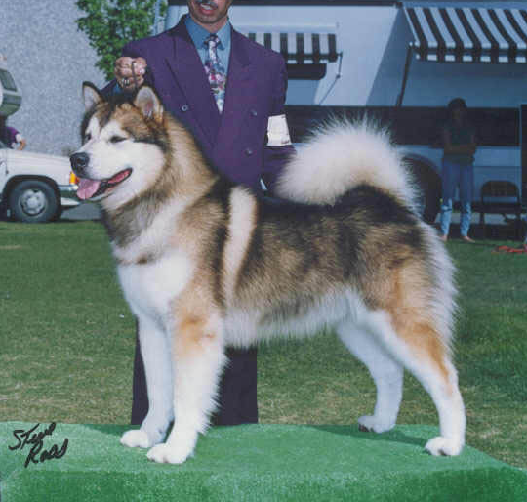 | BISS CH Targhee’s Kodiak ROM | BISS A/C Ch Shamrock’s Kotze Tu B Good ROM | CH Tigara’s Nordisch Kotze Tu ROM | Tigara’s Sam Spade
 |  |  |  | Tigara’s Tonya of Artica
 | BISS CH Targhee’s Kodiak ROM | BISS A/C Ch Shamrock’s Kotze Tu B Good ROM | CH Snocre’s Panik | CH Glacier’s Storm Kloud CD ROM
 |  |  |  | CH Snocre’s Sikku
 | BISS CH Targhee’s Kodiak ROM | BISS CH Skookum’s Mika of Tugidak ROM | BIS, BISS CH Williwaw’s Tugidak of Kalyuh | CH Snopaw’s Snoqualmie CD ROM
 |  |  |  | CH Williwaw’s Chena CD
 | BISS CH Targhee’s Kodiak ROM | BISS CH Skookum’s Mika of Tugidak ROM | CH Far North’s Tansa | CH Baronof ROM
 |  |  |  | Land O’Toba’s Tanana
 | CH Williwaw’s Ivaloo of Targhee ROM | BIS, BISS A/C CH Williwaw’s Sunbear of Targhee ROM | BIS, BISS CH Targhee’s Chipawa Chipper | CH Williwaw’s Kakooshka ROM
 |  |  |  | CH Skookum’s Mika of Tugidak ROM
 | CH Williwaw’s Ivaloo of Targhee ROM | BIS, BISS A/C CH Williwaw’s Sunbear of Targhee ROM | CH Williwaw’s Shemya CD | CH Tenakee Chief CD
 |  |  |  | CH Williwaw’s Chena CD
 | CH Williwaw’s Ivaloo of Targhee ROM | Marlaska’s Frosty Lady CD | Choctaw IV | CH Baronof ROM
 |  |  |  | Tote-Um’s Kula
 | CH Williwaw’s Ivaloo of Targhee ROM | Marlaska’s Frosty Lady CD | Sheba Of Nason Ridge | Lobo of White Bear Valley
 |  |  |  | Fancy Pants
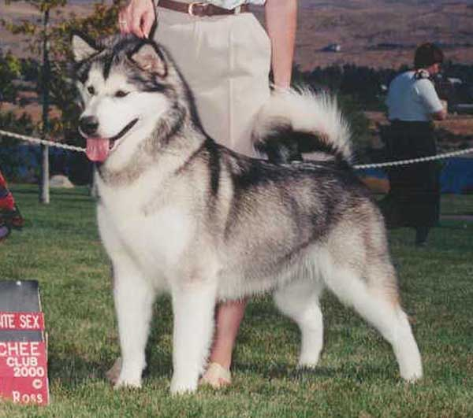  Am/Int CH Williwaw’s Falling Star | BIS, BISS Am/Can CH Braemal’s Alyeska Tuaq ROM | BIS, BISS A/C CH Williwaw’s Kodiak Club ROM | BISS CH Targhee’s Kodiak ROM | BISS A/C Ch Shamrock’s Kotze Tu B Good ROM
 |  |  |  | BISS CH Skookum’s Mika of Tugidak ROM
 | BIS, BISS Am/Can CH Braemal’s Alyeska Tuaq ROM | BIS, BISS A/C CH Williwaw’s Kodiak Club ROM | CH Williwaw’s Ivaloo Of Targhee ROM | BIS, BISS A/C CH Williwaw’s Sunbear of Targhee ROM
 |  |  |  | Marlaska’s Frosty Lady CD
 | BIS, BISS Am/Can CH Braemal’s Alyeska Tuaq ROM | A/C CH Sno Buck’s Spirit of The Sun CD | Can CH Sno Buck’s Haida Chief | Silversheen’s Silver Bear
 |  |  |  | Can CH Sunshine V
 | BIS, BISS Am/Can CH Braemal’s Alyeska Tuaq ROM | A/C CH Sno Buck’s Spirit of The Sun CD | CH Chukchi’s Chilcotin | A/C CH Chukchi’s Athabascan Warrior CD
 |  |  |  | A/C CH Chukchi’s Susquehanna Star
 | Snowtip’s Williwaw Windance ROM | BIS, BISS CH Nanuke’s A Rushin Revolution ROM | BIS, BISS CH Nanuke’s Winter Magic ROM | BIS, BISS A/C CH Northeast Lucan
 |  |  |  | Can CH Northeast’s Misty Minx
 | Snowtip’s Williwaw Windance ROM | BIS, BISS CH Nanuke’s A Rushin Revolution ROM | CH Northeast Scarlet Fever ROM | BIS, BISS A/C CH Barrenfield’s Rocket Torpedo ROM
 |  |  |  | CH Northeast’s Windsong
 | Snowtip’s Williwaw Windance ROM | A/C CH Williwaw’s Silver Eagle | BIS, BISS A/C CH Williwaw’s Kodiak Club ROM | BISS CH Targhee’s Kodiak ROM
 |  |  |  | CH Williwaw’s Ivaloo of Targhee ROM
 | Snowtip’s Williwaw Windance ROM | A/C CH Williwaw’s Silver Eagle | CH Williwaw’s Rain Dancer | BISS CH Targhee’s Kodiak ROM
 |  |  |  | CH Williwaw’s Ivaloo of Targhee ROM

